Borrowing Books and Toys

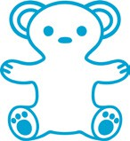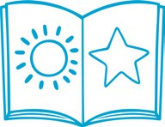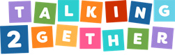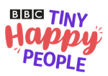

# Borrowing Books

Sitting down and looking at a book with your child is a great way to support their speech, language, communication and attention skills. Borrowing books from your local library is

a great way to access a range of different books with your children, without the barrier of cost.

# Borrowing Toys

A toy library allows you to loan and borrow toys for a period of time, free of charge. It is a great way to try a range of different toys to support your child’s development.

# Local Book Libraries

You can borrow a range of books from 14 libraries in Newcastle. Find a local library near you:

**QR**

[**Libraries in Newcastle | Newcastle City Council**](https://www.newcastle.gov.uk/services/libraries-culture/libraries-newcastle)

**Edit this text for your local setting**

# Local Toy Libraries

Newcastle Action for Parent and Toddler Groups Initiative (NAPI) has a well - established Toy Library service. The toy library services are open to all parents, toddler groups and playgroups.

**Book a toy:** You can loan up to 4 toys to borrow for 4 weeks free of charge. The toys can be selected from the catalogues at your local library.

**QR**

[**Book a Toy Loan Service - Little Borrowers (napi.org.uk)**](https://napi.org.uk/toy-library/little-borrowers-online-catalogue) **Edit this text for your local setting**